# Ex. No. 2 OBSTACLE DETECTION AND ALERT SYSTEM USING INFRARED SENSOR AND ARDUINO

**OBJECTIVE:**

To develop a simple application which detects obstacle and gives alert using Infrared Sensor and Arduino.

# REQUIRED COMPONENTS:

* Arduino UNO
* Arduino IDE
* IR Sensor
* Breadboard
* USB cable for uploading code into Arduino UNO
* Jumper Wires

# BACKGROUND THEORY:

An infrared proximity sensor or IR Sensor is an electronic device that emits infrared lights to sense some aspect of the surroundings and can be employed to detect the motion of an object. As this is a passive sensor, it can only measure infrared radiation. This sensor is very common in the electronic industry to design an obstacle avoidance robot or any other proximity detection-based system.

# IR Sensor Pinout

The IR sensor has a 3-pin connector that interfaces it to the outside world. The connections are as follows:

# IR Sensor Pinout

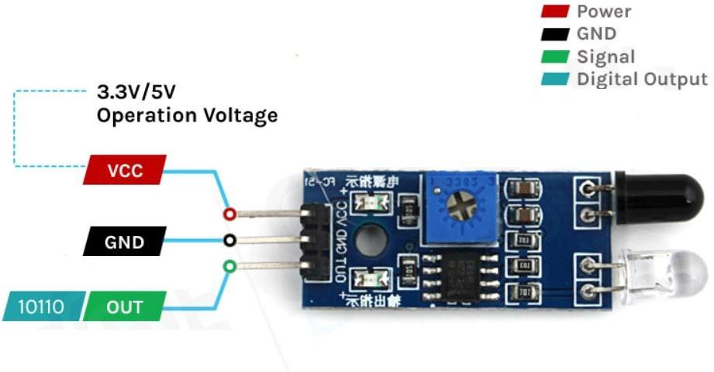

**IR Sensor Pinout**

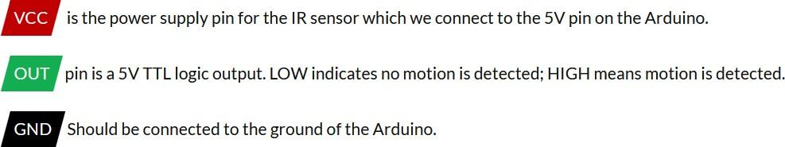

# WORKING:

The working of the IR sensor module is very simple, it consists of two main components: the first is the IR transmitter section and the second is the IR receiver section. In the transmitter section, IR led is used and in the receiver section, a photodiode is used to receive infrared signal and after some signal processing and conditioning, the output will be obtained.

# Working of the IR Sensor Module

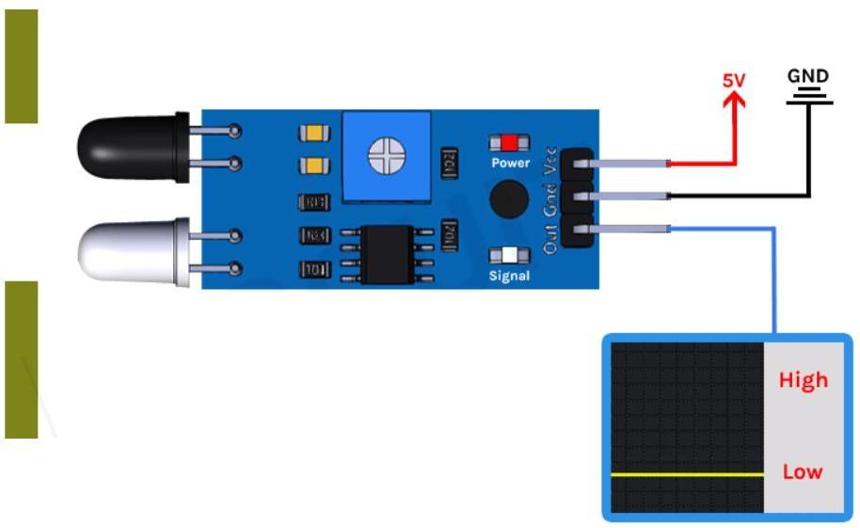

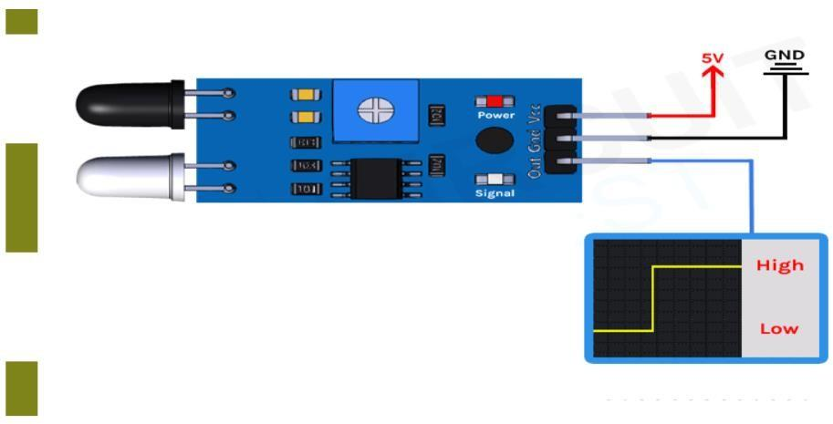

**Working of the IR Sensor Module**

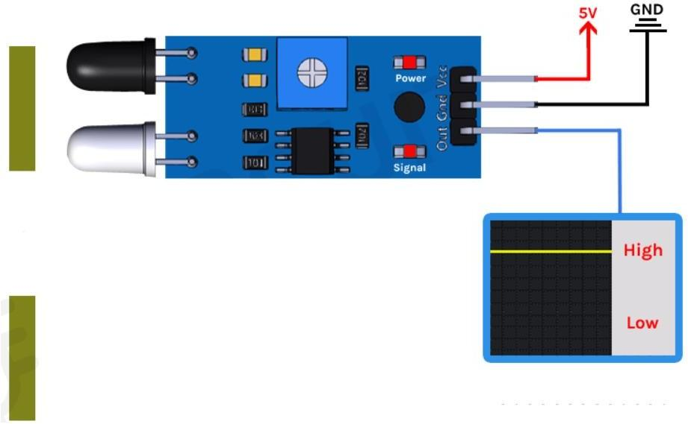

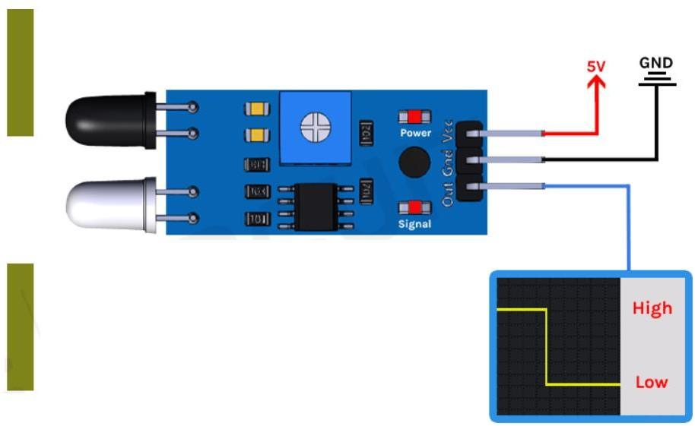

An IR proximity sensor works by applying a voltage to the onboard Infrared Light Emitting Diode which in turn emits infrared light. This light propagates through the air and hits an object, after that the light gets reflected in the photodiode sensor. If the object is close, the reflected light will be stronger, if the object is far away, the reflected light will be weaker. If you look closely toward the module. When the sensor becomes active it sends a corresponding Low signal through the output pin that can be sensed by an Arduino or any kind of microcontroller to execute a particular task. The one cool thing about this module is that it has two onboard LEDs built-in, one of which lights on when power is available and another one turns on when the circuit gets triggered.

**IR Motion Sensor Module – Parts**

IR sensor is used to detect proximity or to build obstacle avoidance robots. This Sensor is popular among beginners as these are low power, low cost, rugged, and feature a wide sensing range that can be trimmed down to adjust the sensitivity.

# IR Motion Sensor Module – Parts

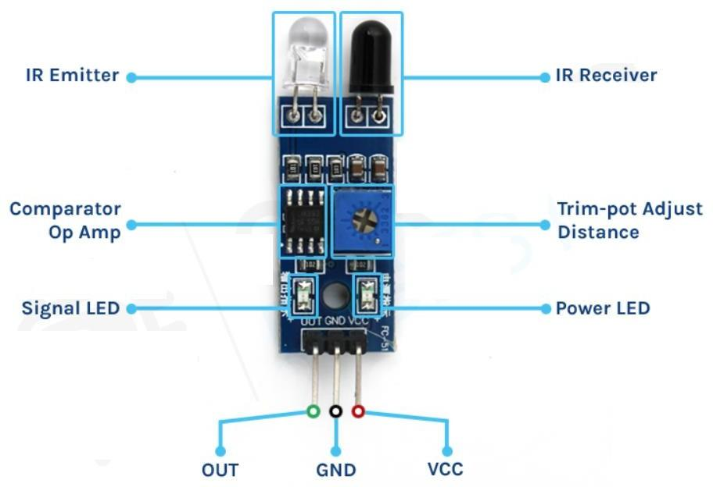

This sensor has three pins two of which are power pins leveled VCC and GND and the other one is the sense/data pin. It has an onboard power LED and a signal LED the power LED turns on when power is applied to the board the signal LED turns on when the circuit is triggered. This board also has a comparator Op-amp that is responsible for converting the incoming analog signal from the photodiode to a digital signal. It also have a sensitivity adjustment potentiometer; with that, the sensitivity of the device can be adjusted. Last and finally, it has the photodiode and the IR emitting LED pair which all together make the total IR Proximity Sensor Module.

# CONNECTION DIAGRAM:

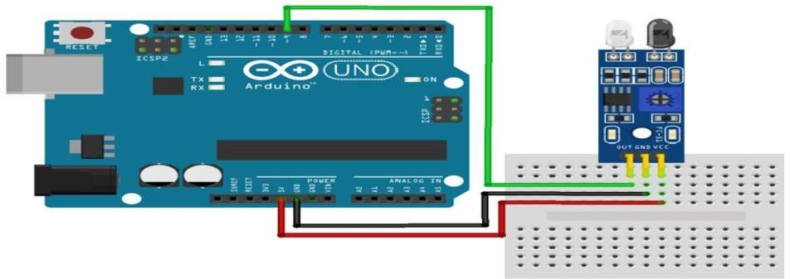

**CODING:**

// Arduino IR Sensor Code

int IRSensor = 9; // connect ir sensor module to Arduino pin 9 int LED = 13; // conect LED to Arduino pin 13

void setup()

{

Serial.begin(115200); // Init Serila at 115200 Baud

Serial.println("Serial Working"); // Test to check if serial is working or not pinMode(IRSensor, INPUT); // IR Sensor pin INPUT

pinMode(LED, OUTPUT); // LED Pin Output

}

void loop()

{

int sensorStatus = digitalRead(IRSensor); // Set the GPIO as Input if (sensorStatus == 1) // Check if the pin high or not

{

// if the pin is high turn off the onboard Led digitalWrite(LED, LOW); // LED LOW

Serial.println("Motion Ended!"); // print Motion Detected! on the serial monitor window

}

else

{

//else turn on the onboard LED digitalWrite(LED, HIGH); // LED High

Serial.println("Motion Detected!"); // print Motion Ended! on the serial monitor window

}

}

# OUTPUT:

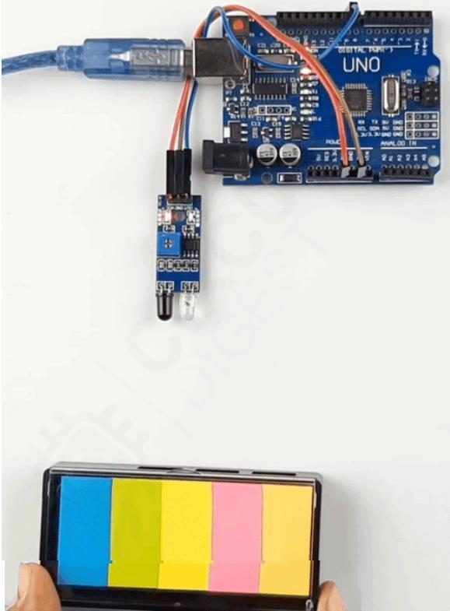

**NO OBSTACLE DETECTED**

# OBSTACLE DETECTED

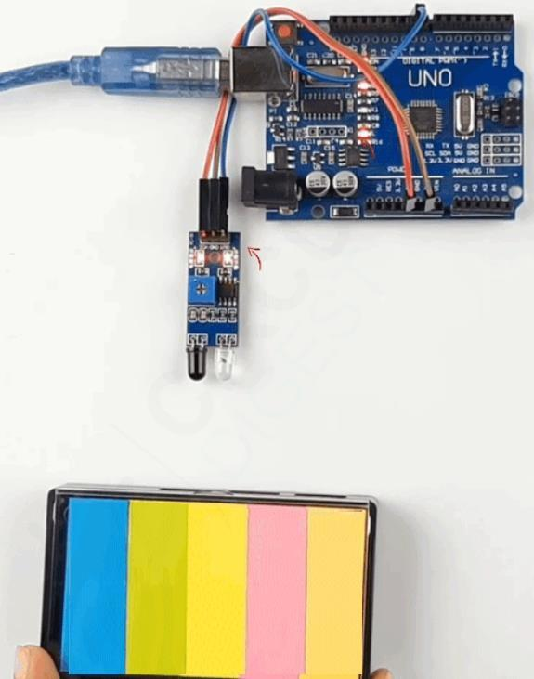

**CONCLUSION:**

Thus a simple application to detect obstacle and to give alert using Infrared Sensor and Arduino is developed successfully.